DESIGN SPECIFICATION

FOR THE

ELEVATE MULTI-OIL LEVEL INDICATOR
AUTOMATION OF THE OLS TEST BENCH

ALLEN AIRCRAFT PRODUCTS, INC.

REPORT #260826

PREPARED BY:
Rick Ales, R. Ales Consulting LLC

REVIEWED BY:
George J. Bush, Chief Engineer

APPROVED BY:
Rob Hyde, Engineering Manager

ALLEN AIRCRAFT PRODUCTS, INC.

RAVENNA, OHIO

RECORD OF REVISIONS
REV. LTR. | DESCRIPTION | DATE | APPROVAL
Draft 1 | Initial Draft | 2025/03/02 | R. Ales
Draft 2 | Change from HW spec to Design Spec, Included LabVIEW & Configuration Management. | 2026/08/24 | R. Ales
Draft 3 | Added Report Number. General updates to document format. Correcting typos. | 2026/08/26 | G. Bush

Table Of Contents
Paragraph Page
1.0 Introduction 5
1.1 Reference Documents: 5
1.2 Notation 5
2.0 Multi Level Oil Indicator (MLOI) System Overview 5
2.1 MLOI Test Protocol 6
3.0 MOLI Hardware Project Overview: 7
3.1 Hardware Architecture 7
3.1.1 Tank Hardware 8
3.1.2 Instrumentation 10
3.1.3 Interface Unit 12
4.0 Software Architecture 15
4.1 MLOI Test Protocol State Transition Analysis 16
4.1.1 MLOI Top Level Thread Architecture 16
4.1.2 Main Loop Initialization 17
4.1.3 DataQ Loop Initialization 17
4.1.4 DataQ Loop 18
4.1.5 DataQ Loop Close 18
4.1.6 Main Test Loop 18
4.1.7 Main Close & Exit 19
4.1.8 Event Loop 19
4.2 LabVIEW Documentation 19
4.2.1 GitHub Repositories Overview 19
4.2.2 AAP_MLOI Repository 20
4.2.3 PM_Folder Repository 20
4.2.4 PWC_OLS Repository 21
4.2.5 Virtual Instrument (VI) Documentation 21
5.0 Configuration Management 21
5.1 Software Versioning 22
5.2 Git Branching Strategy 22
5.3 Setting up Git 23
5.3.1 Step 1: Configure Git 23
5.3.2 Step 2: Initialize a New Repository 23
5.3.3 Step 3: Cloning an Existing Repository 24
5.4 Pull from GitHub 24
5.5 Building the LabVIEW App Executable 25
5.5.1 Configuring the LV Project 25
5.5.2 Building the Executable 26
5.6 Deploying the LV app to the target test-PC. 28
5.7 Using Git Hints 29
5.7.1 Creating a Local Project Folder 29
5.7.2 Switching to a Remote Branch 30
5.7.3 Switching to a Previous Commit 31
5.7.4 Create a new branch and save to remote GitHub 34
5.7.5 Add a Prefix to the Names of Multiple Files in Power Shell 35

- Introduction
The following document sets forth both the design specification and the implementation development of the Multi-Level Oil Indicator (MLOI) program for automating the acceptance testing of oil level sensors. The scope of this specification is the hardware, including the tank, pump and instrumentation required for automating production tests of Allen Elevate 8005571.05 (P&WC 30Y0241-01) and 8005572.05 (P&WC 30Y0241-02) Oil Level Sensors.
  - Reference Documents:
Technical Requirements For The Multi-Oil Level Indicator Automation of The OLS Test Bench, Report #250129
Tank, Multi-Unit Test Tank, Drawing No. T-20037
  - Notation
LV LabVIEW
MLOI Multi-Level Oil Indicator, designation of the automated tester described herein.
AAP Allen Aircraft Products
ATP Acceptance Test Procedure
DS Design or Development Specification
OLS Oil Level Sensor
DUT Device Under Test
AI Analog Input
XL MS Excel
IC Integrated Circuit

- Multi Level Oil Indicator (MLOI) System Overview
MLOI has different operator panels based on various use cases to minimize distraction for the test operator while maximizing flexibility for the Test Engineer.
- Environment
  - Production – LabVIEW Runtime Engine
  - Maintenance – LabVIEW Professional Development System
- Mode
  - Production – default, Test Operation in Production Environment.
  - Maintenance – offers the Developer / Test Engineer additional test and debug controls.
- Method
  - Production – OLS Resistance via DataQ and closed loop tank control (default in Production Environment).
  - Simulated – Generated Test Resistor and Level data used for debug, test and training
- Test Type
  - Post-Pot – A Stepped Level ATP test with OLS resistance evaluated at specific Set Point in the Switch Zone.
Pre-Pot – User determines the level set point manually to help set the PCB position
  - MLOI Test Protocol
The ALLEN Elevate 8005571.05 and 8005572.05 Oil Level Sensors document sets forth the requirements of the Multi-Level Oil Indicator (MLOI) program for automating the acceptance testing of oil level sensors. The MLOI program is divided into phases or epics. The first epic is for automating production tests of Allen Elevate Oil Level Sensor In particular the Oil Level Test Bench protocol .
The Oil Level Sensor produces a discrete resistance value for two channels, A & B proportional to a range of Levels specified.
The Level limit specifications are different for filling and draining to account for device hysteresis.
The ATP specifies two zones based on the oil level range (See Figure 1):
- Measurement zone – Where the resistance level must be discrete steady state value within tolerance limits over the entire specified range.
- Switch Zone -- between measurement zones where the resistance changed from one values to the next. The Resistance switching value transition, (ie the Switch Point) occur before the Oil Level exceeds the specified switch zone exit level limit.
The measurement uncertainly is determined by a Type 1 Gage study. This “Target Test Point Uncertainty” results in a safety margin applied to the test specification to determine the evaluation “test target point” that minimizes the likelihood of a Type I Error (α =0.05)
A pre-Fill and pre-Drain are performed before the test to ensure the DUT is lubricated.
The Fill Spec exit Limit is the Lower switch zone spec while the Drain Spec exit Limit is the higher switch zone spec.
PASS/FAIL Criteria, DUT FAILS if:
- Resistance is not within tolerance at each of 42 Target Test Points after a minimum of .3 second settling time as prescribed in section 5.6 of ATP’s for Elevate Oil Level Sensors.
- Resistance is not within tolerance any time Durning the Measurement Zone.

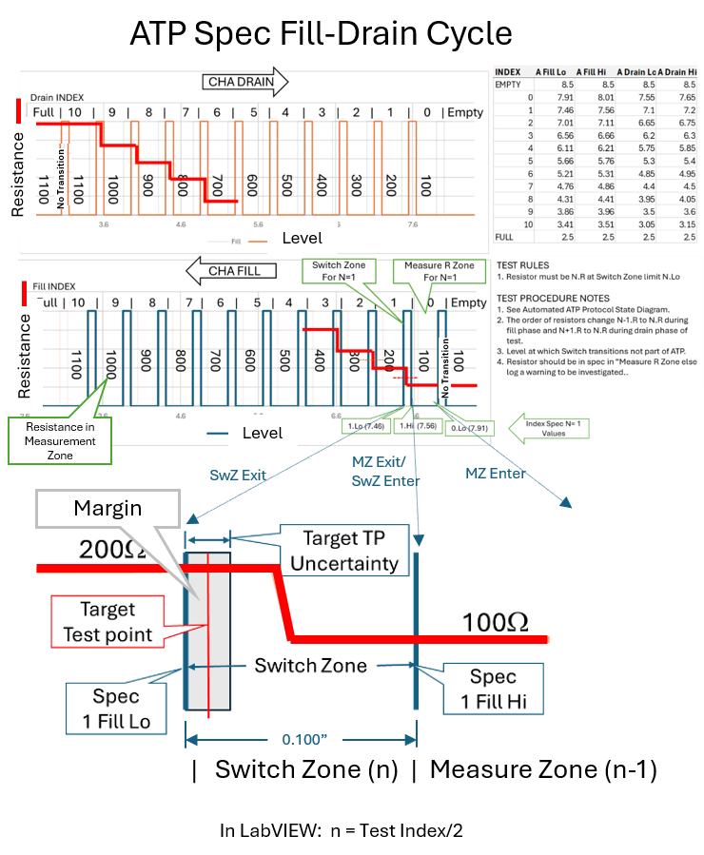
Figure 1. MLOI System Test Protocol
- MOLI Hardware Project Overview:
The project hardware including the tank, pump and instrumentation also has two phases as follows:
- HW 1 – Prototype phase where all items are COTS and custom configurations are achieved through breadboards or otherwise temporary connections.
- HW 2 – Production where custom interfaces have been designed and fit for purpose implemented, i.e. interface unit manufactured as a custom PCB.
  - Hardware Architecture
The hardware consists of a tank, the Instrumentation, and an Interface Unit as shown in Figure 2. The PC workstation and USB hub are out of scope in this specification.

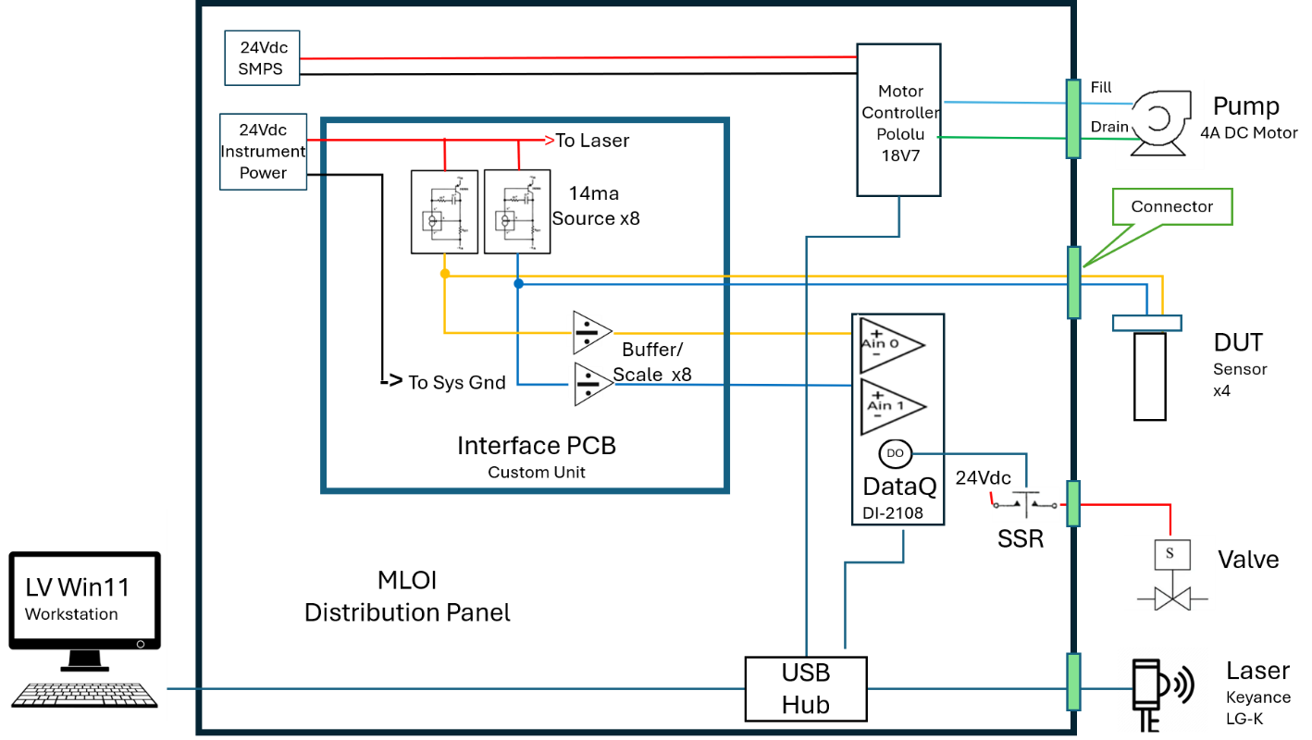
Figure 2. Hardware Architecture, functional diagram

Tank Hardware
The dual-chambered tank includes the with the following components:
- Reservoir is the chamber containing the bulk of the turbine engine oil conforming to MIL-PRF-23699 or MIL-PRF-7808.
- Measurement Well is the chamber into which the sensors are immersed for measurement.
- Sensor Rack Mounting Plate holds the sensors in place during measurements and provides the sensor reference level datum.
- Leveling Feet for leveling the Sensor Rack Plate to the oil level.
- Transfer Pump GP-201-12/24L for transferring oil between the Reservoir and the Measurement Well.
- Back flow preventer solenoid valve.
- Miscellaneous brackets for mounting instrumentation.

      - The Tank / Pump open loop system response
Using the Pololu MC18V7 PWM motor controller with Vs set to 24Vdc, The Δ Level was measured for 30 seconds at various percent of max speed (100% duty cycle) for both FILL and DRAIN at near EMPTY and near FULL.
The response has a minor shift at each case but is basically linear down to about 5% resulting in fill rate of about 0.1”/min where the control becomes unstable by 4% as shown in the ‘Zoomed In Plot in Figure 3.
Without doing an extensive fluid analysis, this response is assumed to be adequate for the MLOI application. Data from mloi:\PM_Folder\_3 Develop\Design Calculations.xlsx sheet Tank.
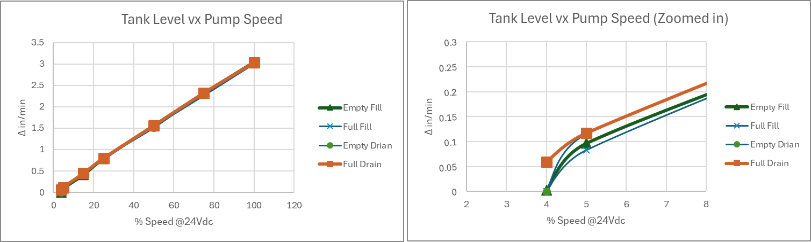
Figure 3. Tank / Pump level response.

Step settling with 3-speed Servo Pump Control
As currently designed, the Pump is controlled by a 3-speed servo controller implemented in LV. The Pump is driven at FAST, SLOW and CREEP speeds over the corresponding speed ranges based on the error (Set Point minus Process Variable, e = SP – PV) Thes “pump parameter” are settable in the $Configuration File where speed is specified in terms of percent of maximum Pump flow rate of 100%. Figure 4 shows the level step at 600Ω filling towards 700Ω. Figure 4, shows the level zoomed-in to the 0.001” per tick, over the 3-second pause for measurement.
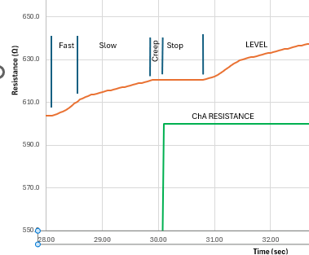
Figure 4.

Controller Idle Speed and Dead Band
The controller Switches speeds at the following levels configurable in the $ConfigFile:
Parameter (%Error) | Speed Switch with decreasing error
 | Fast to Slow
  RNG_Slow
RNG_Creep | Slow to Creep
RNG_Stop | Dead Band
WAIT_In_Idle | Delay switching to STOP state.
The Dead Band is required to manage the pump hunting at zero error. When the Error reaches the Dead Band, the controller switches to IDLE State where the error is driven towards zero should the error becomes larger than RNG_Stop. Once the error remains less than RNG_Stop for at least WAIT_in_Idle seconds then the controller switches from IDLE to STOP State.
If the error value exceeds hard coded start band of 0.02, then the 3-speed controller becomes active again. This value could be parametrized in the $ConfigFile.
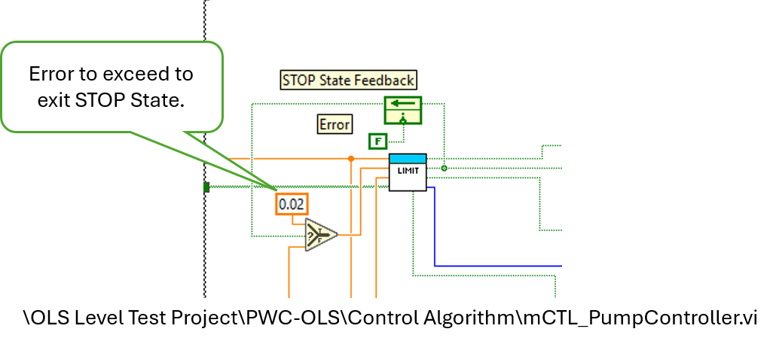
Backflow Valve
A solenoid valve is added between the sump pump and the tank to prevent any leakage through the pump that would affect the tank level. This solenoid valve is discretely switched between open and closed by a Solid-State Relay (SSR) which is controlled by a Discrete output on the DataQ.

Instrumentation
The instrumentation provides Level measurement (Keyance Laser LK-G500) and two resistance measurements for each sensor DUT (DataQ DI2108) and provides directional DC motor control (Pololu MC18V7) via Universal Serial Bus (USB).
Level Measurement - Keyance Laser LK-G500
The Keyance Laser LK-G500 is a spot beam, displacement measurement laser, tune for +500mm (19.6”).
Key Specifications
Linearity ±0.05% of F.S. (-250 to +250 mm) (9.8” to 29.5”) or 0.015”
Repeatability 3μm or 0.0001”
Temperature characteristics 0.01% of F.S./°C (F.S. = ±250 mm) or 0.003”

      - Resistance Measurement -DataQ DI2108
The DI-2108-P data acquisition instrument is a portable data recording module that communicates through your computer's USB port. Power is derived from the interface port so no external power is required. Features include:
Analog Inputs
Number of Channels: 8
Channel Configuration: Differential
Measurement range per channel: Programmable ±2.5, ±5, ±10, 0-5, 0-10 Volts
Input impedance: 800 kΩ differential
DC accuracy: ±0.05% of range 25°C
Absolute maximum input: ±150 V dc or peak ac
ADC Characteristics
Resolution: 16-bit
Resolution applied to measurements: >15.6-bit
Max. sample throughput rate: 160 kHz throughput
Min. sample throughput rate: Hardware: 1.831 kHz
with WinDaq software: 0.305 Hz
Sample rate timing accuracy: 100 ppm (typical over 24 hours)
Digital Ports
Number of Ports: 7
Type: MOSFET switch
Configuration: Programmable as digital input or switch
Pull-up value: 4.7 kΩ
Input high voltage threshold: 2.4V
Input low voltage threshold: 0.8V
Absolute maximum applied voltage (V): 0 ≤ V ≤ 25 V

      - Motor Controller - Pololu MC18V7
A general purpose motor controllers for brushed, DC motors with USB connectivity.
Key Specifications
Maximum voltage 30Vdc
Maximum current 7A

Interface Unit
The interface unit provides one fixed current reference circuit (I_{s}) as sensor signal stimulus to a single sensor channel so sensor channel resistance (R_{chx}) can be calculated from the sensor signal (V_{m}):
R_{chx} = V_{m} / I_{s} where V_{m} is the measured voltage from the sensor.
The interface unit also provides a one buffer/scaler circuit to condition a single Sensor signal to the range of corresponding Analog Input (AI).
The interface unit provides a place to mount the Pololu Motor Controller. It also provides a means to connect the system components including the Power Supplies, to Laser and moto controller; and connect the sensor signals to the analog inputs.

      - Reference Current Source Circuit

The Current Source required to drive the sensor signal is implemented with one Linear Technologies LT3092 integrated circuit (IC) for each sensor channel. Parameters for consideration are the reference current (I_{s}) as determined by the in situ current of the OLS to be tested; the compliance voltage (V_{dc}) determined from the required maximum resistance to be measured at I_{s}. The Elevate OLS resistance ranges from 100Ω - 1100Ω with an overrange resistance of 2100Ω with an in situ of 14.7ma, producing a maximum signal voltage V_{s} of 16.7V at 1100Ω. We assume that the overrange resistance does not have to be accurately measured, only detected and that the Laser uses a 24V_{DC} source that can be used to power the Current Source circuit V_{dc}, where the maximum resistance measurement will be 1632Ω. With V_{dc} set to nominal 224V_{DC} following the LT3092 Datasheet Application Information page 9??? (where is this located should add to an Appendix). Then 15Ω is selected for R_{OUT} and 22.0KΩ is calculated for R_{SET} as shown in Figure 5.
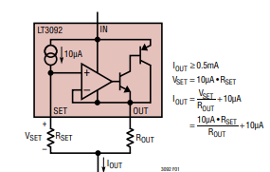
Figure 5. LT3092 Current Source Circuit

      - Buffer/Scaler Circuit
The Buffer/scaler circuit addresses two issues with the DI-2108:
- Limited input voltage range
- Relatively low input impedance.
To achieve Rin > 1MΩ, a LM2902 unity gain, follower circuit will buffer and isolate the DUT from the Analog Input impedance. With maximum signal voltage V_{s} > 16.7V and the maximum input voltage range of the DI-2108 of +/-10.0V, then V_{s} must be scaled to fit within the input range. This accomplished with voltage divider circuit consisting of R7 (R9) and R8 (R10). where the parallel resistance (Rin = R7 || R9) is greater than 1MΩ. To achieve Rin > 1MΩ, the relatively low 100KΩ input resistance of the DI-2108 shown in Figure 3 needs to be increased by adding a single supply, follower op amp (LM2902).
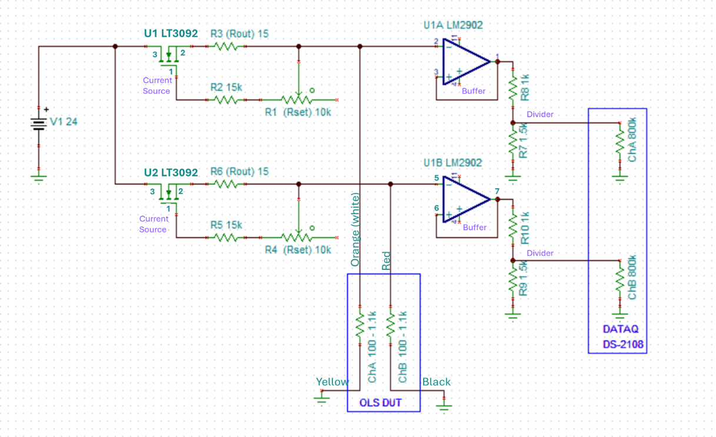
Figure 6. Analog Input Circuit Connectors
    - PCB Implementation
The Schematic was captured and the PCB laid out in Easy Cad EasyEDA - Online PCB design & circuit simulator

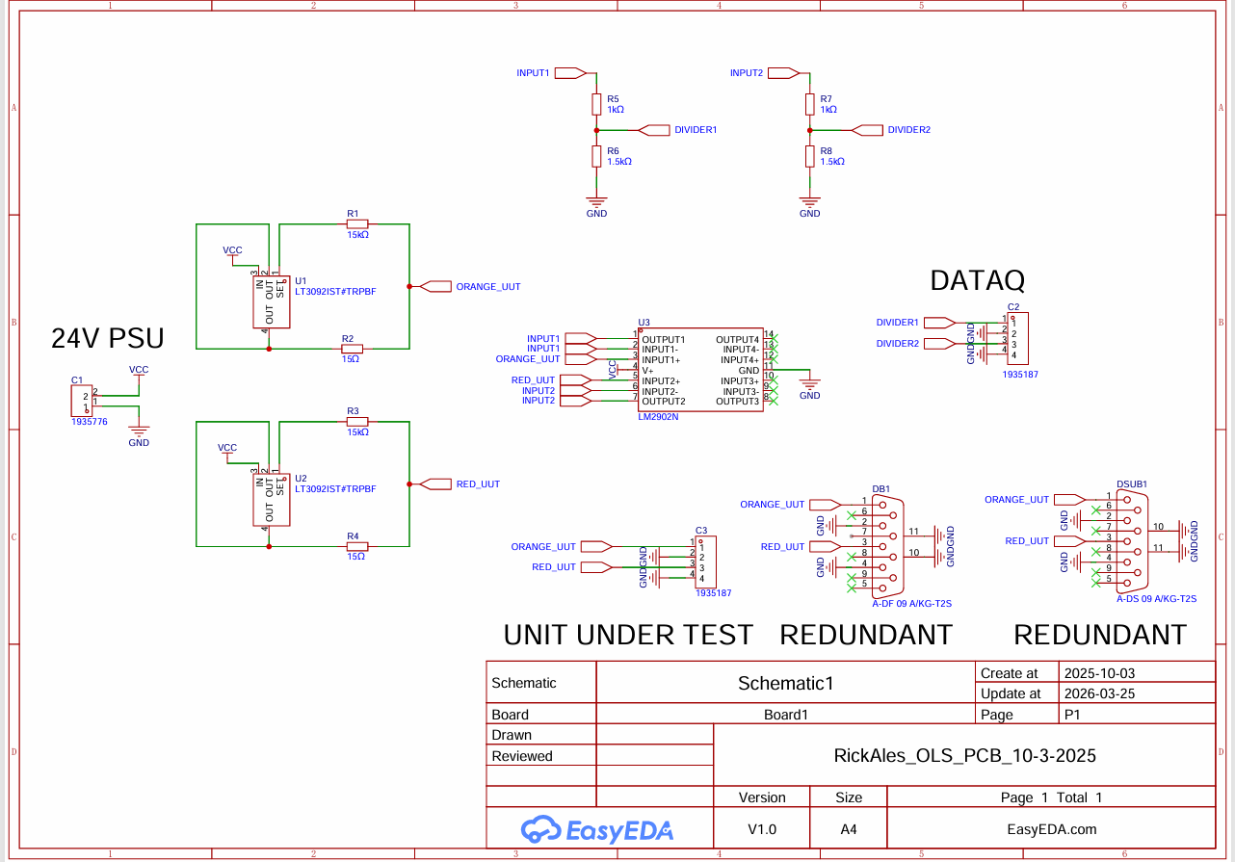
Figure 7. Interface PCB EasyCad Schematic

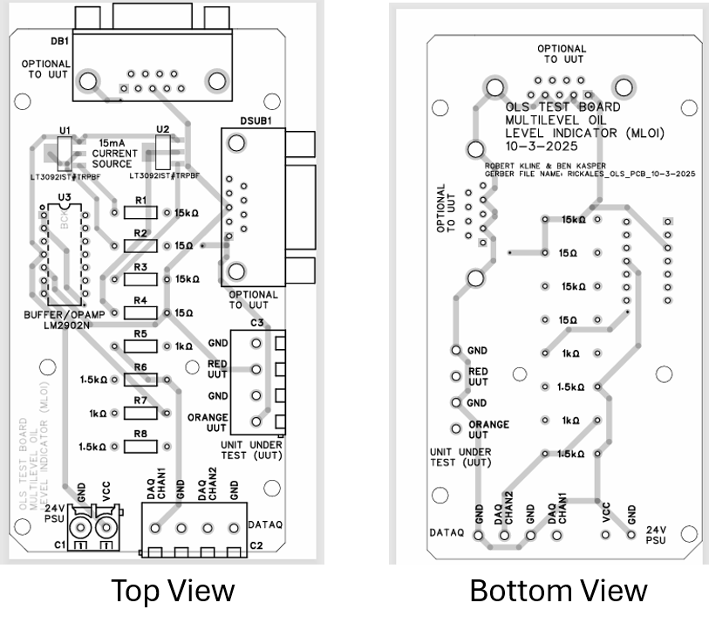
Figure 8. Interface PCB EasyCad Layout
- Software Architecture
Describe/include a figure of the overall system architecture (and where this module fits in)

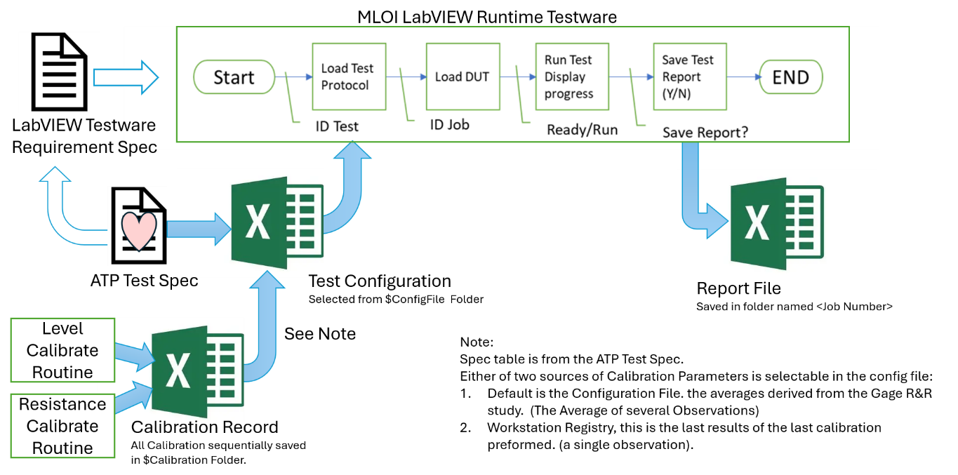
Figure 9. MLOI System and Information Overview

  - MLOI Test Protocol State Transition Analysis

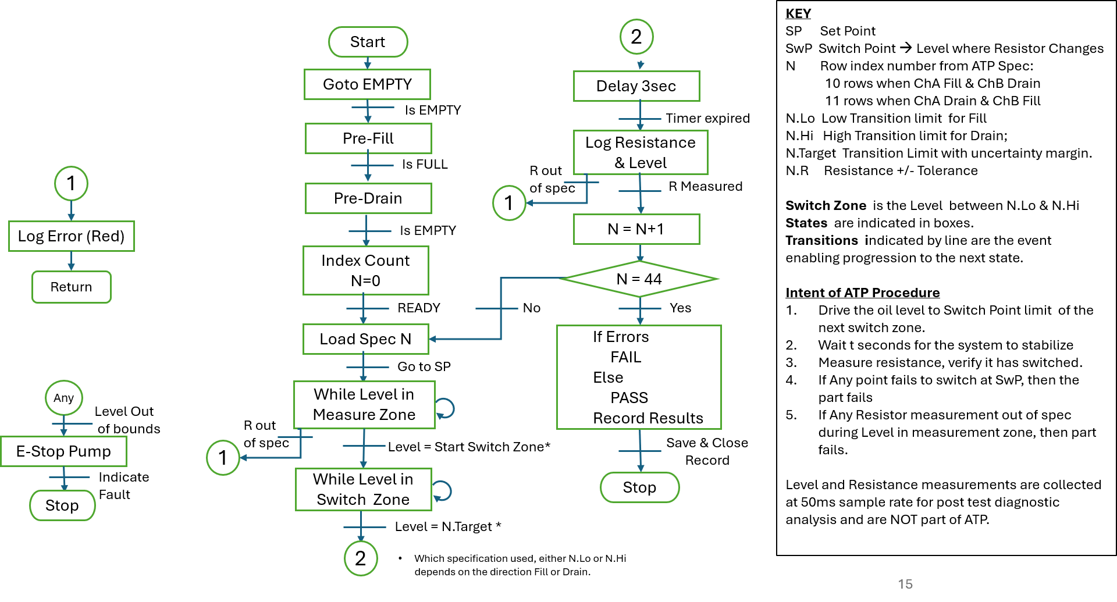
Figure 10. MLOI State Transition Diagram

MLOI Top Level Thread Architecture

The LabVIEW (LV) Application (app) is divided into Three loops
- The Main or Test Loop --Executed the Test Protocol State Machine and controls the Exit function.
- The DataQ Loop – Reads Analog and Digital Inputs (AI & DI) and writes to digital Outputs (DO))
- Event Loop – Handles user input, remote semaphore and launched Sub VI (ie Cal Routines)
Each loop has Initialization, Processing while loop and Close phases. See Figure 11 for the diagram of the LabVIEW Application loops.

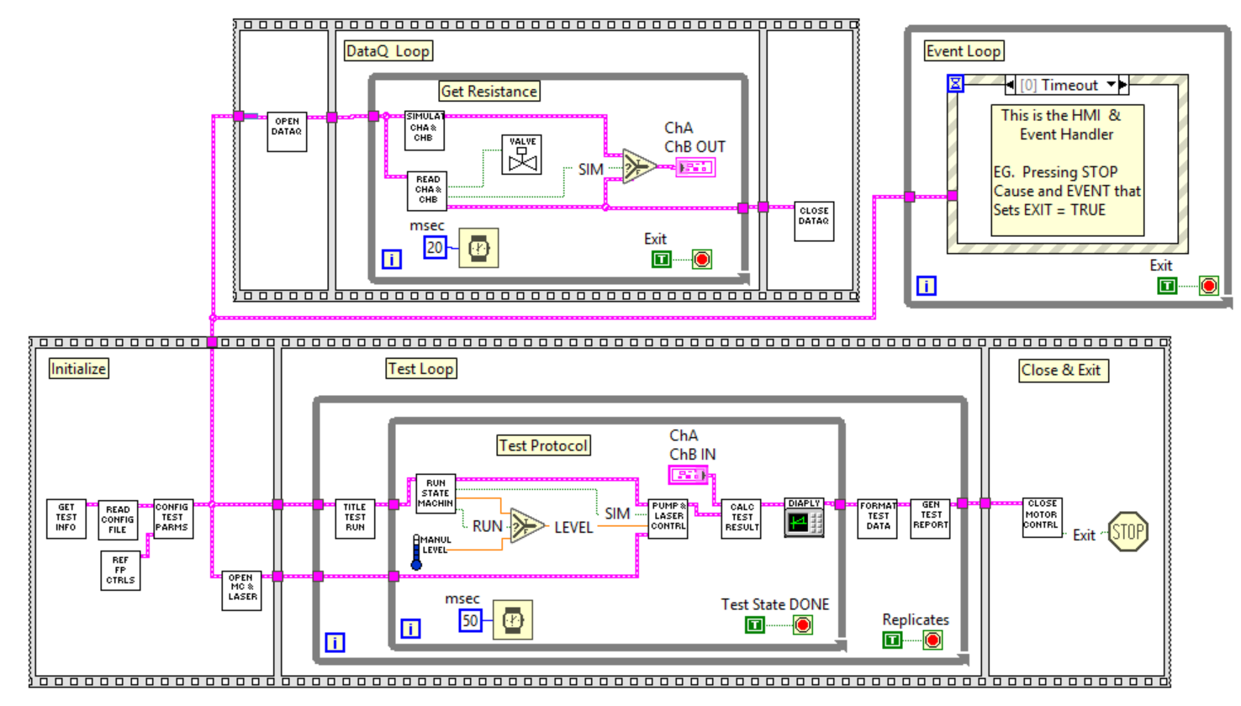Figure 11. LabVIEW Application Loops

Main Loop Initialization
GET TEST INFO -- Upon start up the user dialog prompts the user to select the test type by loading the specified Configuration File and include the Test information ie (Job Number, Unit Number, Serial Number, and set the test parameters Pre or Post pot test, enable pre-fill lubrication phase etc for the Device to be testes. These values are made persistent from Test to Test by being saved to the Windows system Registry.
REF FP CONTRL – Reference Front Panel Controls associated the Front Planel Control to a Reference Number and initialized the that Control or Indicator.
READ CONFIG FILE – Gets the ConfigFile path from the Registry then Reads in the configuration files for the selected test as a Comma Separated Variable (CSV) file.
CONFIG TEST PARAMS --. Configure Test Parameters Sorts the Configuration parameters into 4 Sub Clusters of parameters Bench, Pump, Test and DataQ. Combines the parameters with the Test Information and the control referenced into Full Config Cluster for use throughout the application.
DataQ Loop Initialization
OPEN DATAQ -- Associates DataQ serial communications with Windows Comport, ensures the connection is made, if is loads the DataQ parameters into the DataQ, else presents the option for simulate mode, otherwise

DataQ Loop
ChA & ChB resistance data is produced for use in the Test Loop.

READ CHA & CHB -- Read Channel A and Channel B, If Device is present, captures, filters and scales then presents the data as a resistor value sampled at 20ms rate. Closes the solenoid valve during the Settling Wait Time state.
SIMULATE CHA & CHB -- Read Channel A and Channel B , Eles presents simulated channel resistance based on the Level Input reading.
Ends loop when global “Exit” semaphore is received from is received from the main loop.

DataQ Loop Close
CLOSE DATAQ-- Read Channel A and Channel B, If Device is present, captures, filters and scales then presents the data as a resistor value sampled at 20ms rate. Closes the solenoid valve during the Settling Wait Time state.

Main Test Loop
TITLE TEST RUN –Title Test Run executes in the outer loop which executed once then once more for each configured replicate. The Test Title made up of the test type, the job number, the unit number and a time stamp is applied to as title he report file.
TEST PROTOCOL LOOP – Inner loop that executes the test protocol and the Level Controller in the following modes:
RUN STATE MACH – Run Consists Machine, Algorithm to either:
      - Run -- where the Level SP is automatically determined by the state defined in the Test Protocol for either of two test types: i) Pre-Pot where level is continuously ramped between Empty, to Full to Empty aka AEPS Test. ii) Post Pot where the level is stepped to the switch point for each channel, the resistance is measured and evaluated as Switched (ie Pass) or not-Switched (ie Fail) aka ATP Test.
      - Manual -- where operator has either open loop or closed loop level control.
PUMP & LASER CONTRL -- The Level Controller is 3 speed servo control that that can run either:
      - Automatic -- Closed Loop that drives the Level PV to the Level SP
      - Jog -- Fill and Drain buttons select the direction of the pump and speed.
      - Sim -- Optional Auto and Jog modes where the Level PV is generated from Config Params when Sim is select or either Pump or Laser is off-Line.
Test Protocol loop is exited on the DONE State in Run Mode or when the STOP button is pressed in the Manual Mode
FORMAT TEST DATA – Format the Level & Resistance Data, Test Results, Test Information and Calibration parameters for input to the Test Report.xlsx and include the Test Information .
GEN TEST REPORT – Writes the formatted Test Data into an Excel workbook and saves in the Report File Path.
Test Loop is exited after the last Test replicate is Run
Main Close & Exit
CLOSE MOTOR CONTRL – Close the Motor Controller ensures the motor controller (Pump) is stopped, the value is open, then closed the connection and generates the Global “Exit” Semaphore.
EXIT -- Closed the App and LabVIEW Runtime.

Event Loop
EVENT HANDLER– Checks for asynchronous user input such as the STOP or Menu Items pressed. Handles DIO semaphore form Motor Control. Launches Cal Routines.

  - LabVIEW Documentation
GitHub Repositories Overview
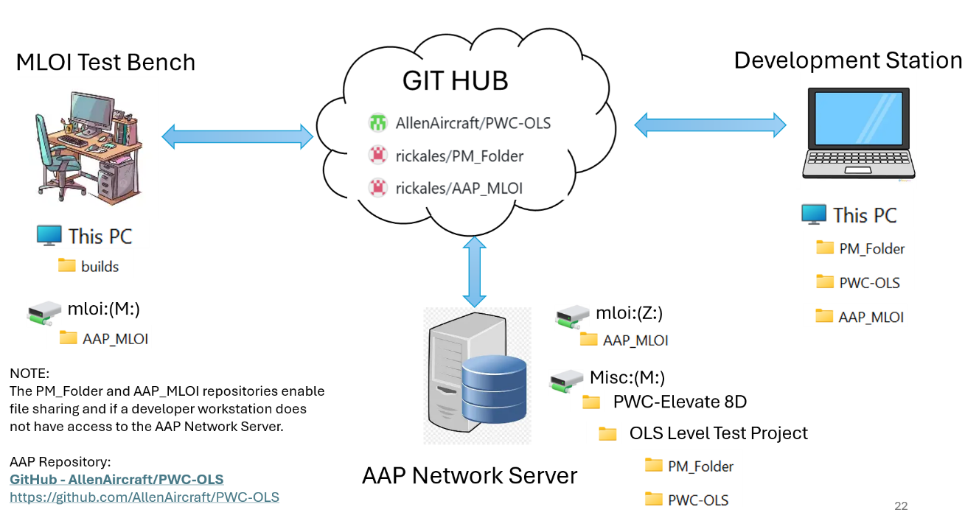
Figure 12. GIT HUB Diagram

AAP_MLOI Repository
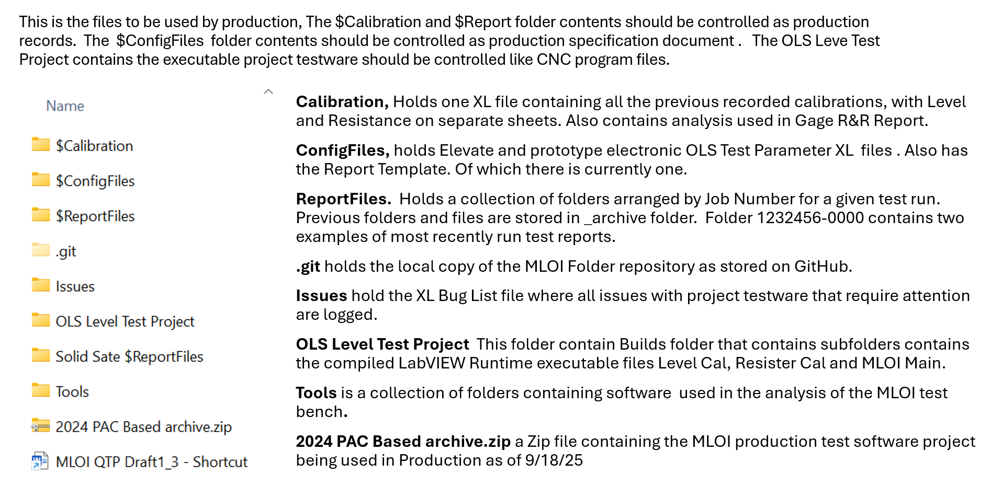

PM_Folder Repository
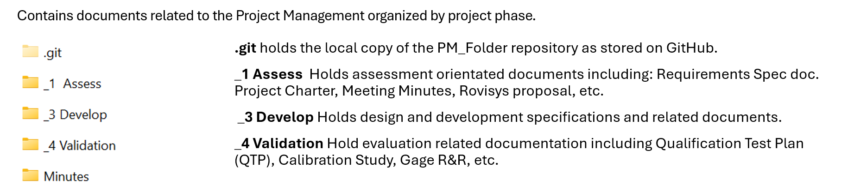

PWC_OLS Repository
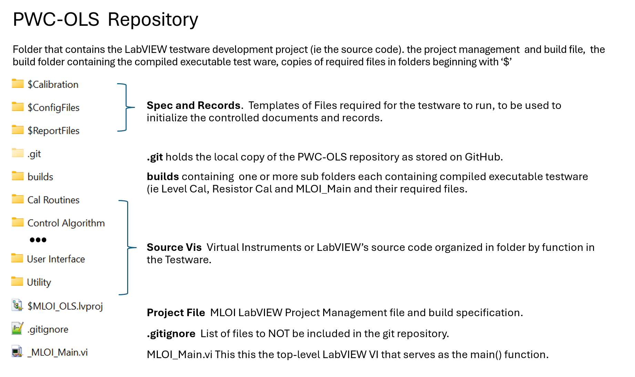
Virtual Instrument (VI) Documentation
In the Block Diagram view of the LabVIEW development system, VI Contextual Help is available for each VI function block when enabled (see Figure 13). Clicking on a VI function block displays a description of the VI function, terminal names and indicates their data type of the function parameters.
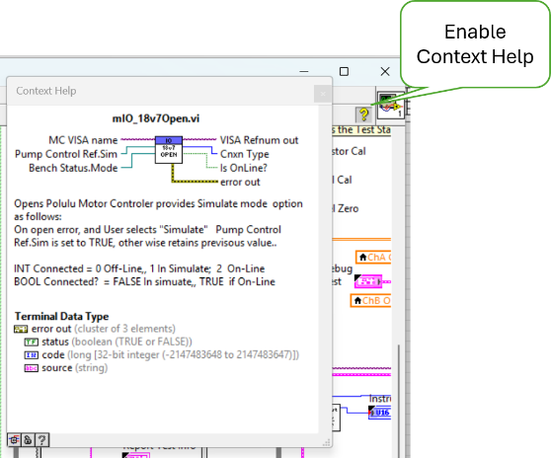
Figure 13. Example of VI Contextual Help

- Configuration Management
Configuration Management practice of tracking and controlling changes to a system.

  - Software Versioning
Version indicator consisting of two values the first is letter representing the Major revision and a number representing a minor revision.

Major revision indicates the following applicability of the code:
  - Where E (Engineering) versions are for development evaluation only.
  - Where Q (Quality) versions are for interdepartmental evaluation but not for production, often referred to as Beta software.
  - Where letters A-D, F-P represent code has been qualified and released for production, the first release starts with A then incremented with a major release defined as not 100% backwards compatible (form, fit and function) with the prior release.
Minor revision are two numbers, incremented with any change that remains 100% backwards compatible, (not materially affecting form, fit or function.)

  - Git Branching Strategy
A branching strategy is a strategy that software development teams adopt for writing, merging and deploying code with the help of a version control system like Git. Since this project is likely to have a single developer the simpler, streamlined branching Github Flow strategy shall be used (see Figure 14).
Main Branch The primary branch of a Git repository where the most recent stable, production-ready code resides.
Feature Branch is a development branch, created to work on a specific feature or task isolated from the main branch. Feature branch code distributed for deployment versioned as the Next release version prefixed with a Q. For example, if the Main Brance is version A02, then the Feature branch implementing a minor change shall be versioned QA03.
Merge: The process of combining changes from one branch into another. In the case of using LabView, the simplest merge would be to simply replace the Main branch with the Feature branch when released.

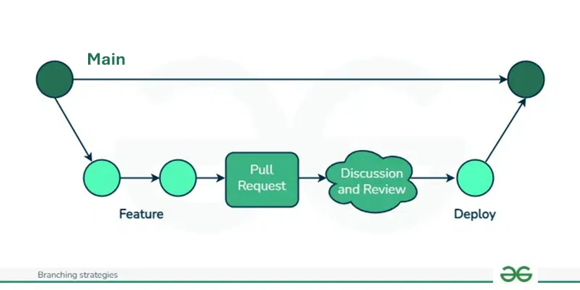
Figure 14. GIT HUB Flow Strategy for MLOI Test Project

  - Setting up Git
Step 1: Configure Git
Before using Git, it’s essential to configure your identity. This information will be included in your commits.
Set your username:
git config --global user.name "Your Name"
Set your email:
git config --global user.email "your.email@example.com"
You can check your configuration settings at any time using:
git config --list
Step 2: Initialize a New Repository
Creating a New Repository
Navigate to your project directory:
cd /path/to/your/project
Initialize the repository:
git init
This command creates a new .git directory in your project folder, marking it as a Git repository.

Add files to the staging area:
git add .
This command stages all the files in your project directory for the initial commit. You can also add specific files by listing them individually.

Commit the files:
git commit -m "Initial commit"
This command commits the staged files to the repository with a message describing the commit.
Connecting Your Local Repository to the Remote Repository
Add the remote repository URL:
git remote add origin https://github.com/AllenAircraft/mloi-ols.git

Connect to an existing remote repository URL:
git remote set-url origin https://github.com/AllenAircraft/mloi-ols.git

Push your local commits to the remote repository:
git push -u origin main

Step 3: Cloning an Existing Repository
If you want to start working on an existing project, you can clone a remote repository to your local machine.
Navigate to the desired directory where you want to clone the repository:
cd /path/to/directory
Clone the repository:
git clone https://github.com/username/repository.git
This command creates a copy of the remote repository on your local machine.

  - Pull from GitHub
Typically, “pull” is used when code is being developed on two or more workstations. To download the latest code to a development station that already has a project cloned:
- Open a command window by typing “cmd” into the Search bar.
- Enter the drive letter followed by a colon (m:) where the project exists.
- Change directory (cd) to the project folder.
- Enter “git pull” to update the local copy of the project from GitHub.

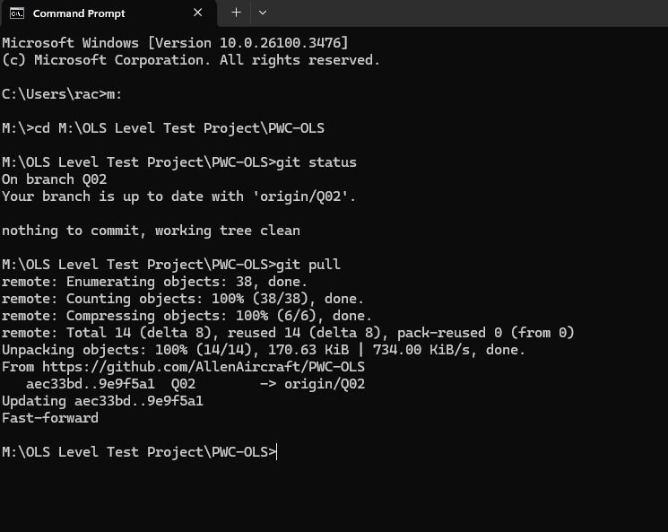
Figure 15. Command Window

  - Building the LabVIEW App Executable
LabVIEW sourced code can only be edited and run in the LabVIEW development system. The project configuration is maintained in the LabVIEW Project file, which also contains the system commands to build the executable. The executable can be run on any Windows PC that has LabVIEW Run-time installed.

Configuring the LV Project
- Add folders and files to be included to the project tree.
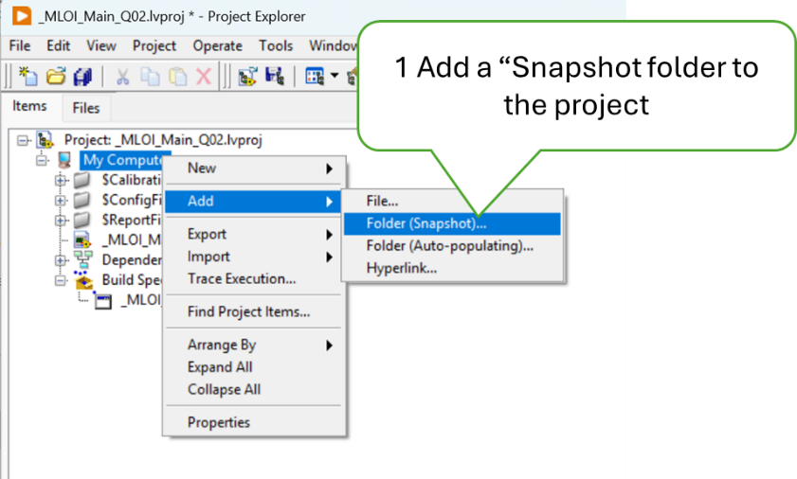

- Include the folders and files in the project.
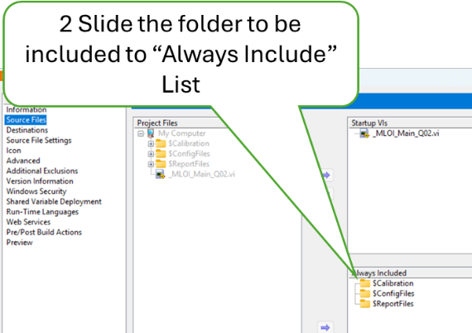

- Add the Destination Folder for each Item to be included.
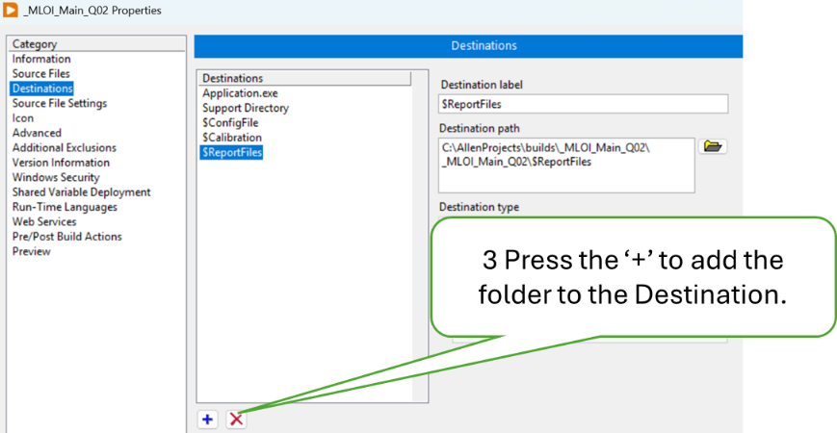

- Link the Project Item it’s Destination Folder.
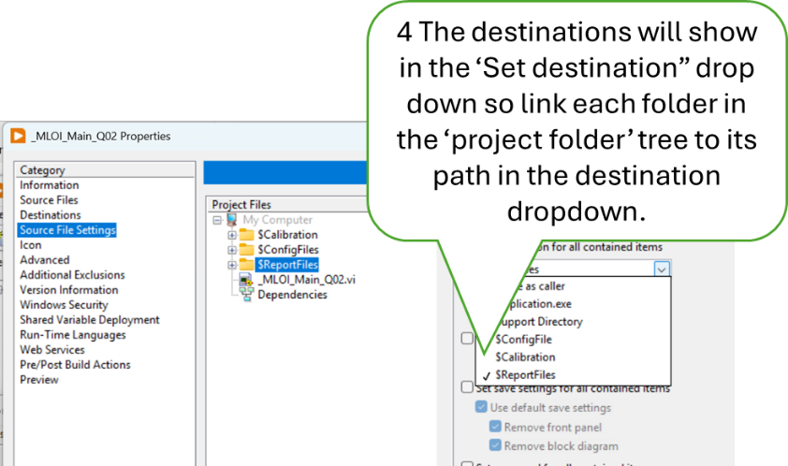

- Turn on the debugger.
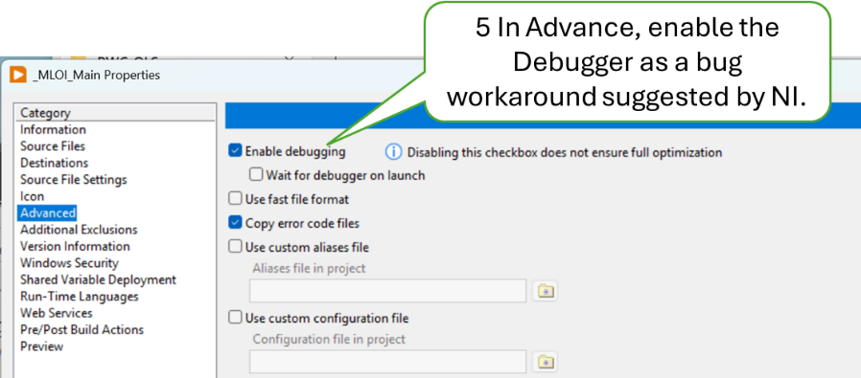
Building the Executable
- In Windows, navigate to the project folder, ..\PWC_OLS
- Select the LabVIEW Project File.

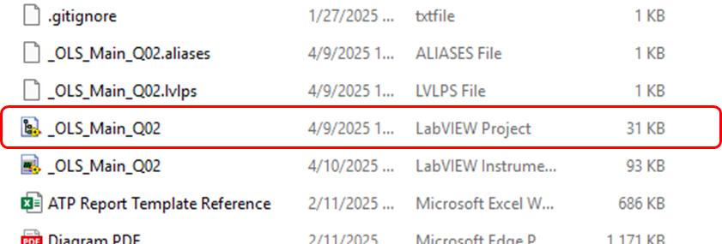

- Expand the build specification branch.

- Double click on the MLOI-OLS Tester icon.

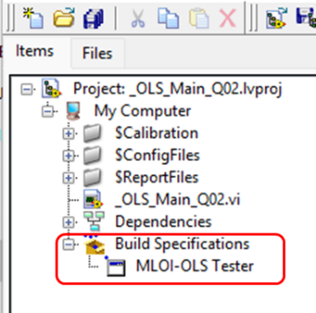

- Click the “Build” Button.
- The default destination folder should be named “builds” in the project folder.
- Save and Close the project folder.
- Open “Cmd” window to upload the build to GitHub
- Navigate to the project folder
- Then git add . (note the ‘.’ is required); git commit -m “some comment”
- And git push does the upload to GitHub.

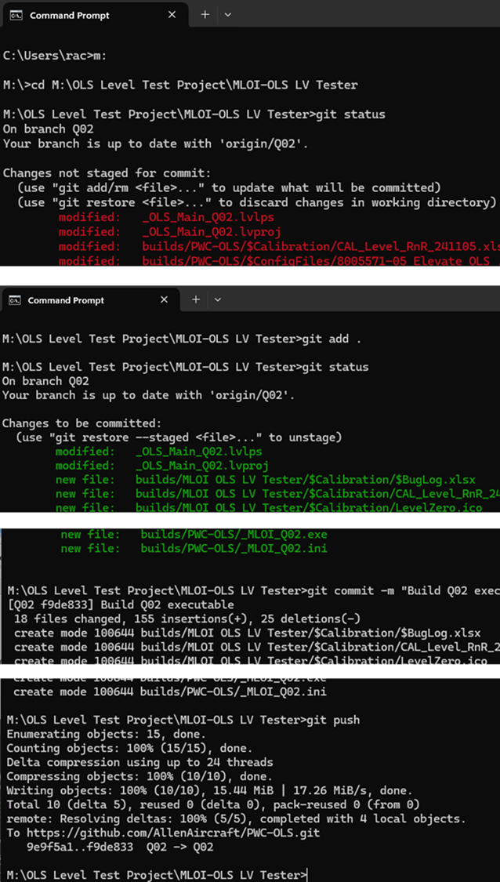
Figure 16. Command Window
  - Deploying the LV app to the target test-PC.
The LV app executable is saved in the Allen Aircraft project on GitHub at GitHub - AllenAircraft/PWC-OLS The easiest way to download the LV app is to download the project as a zip file and extract the MLOI-OLS LV Tester folder to the target PC desktop. Perform the following steps on the Test target PC.

- Use an internet browser to navigate to GitHub-Allen Aircraft/PWC-OLS. Click on Code button.
- Select the Version of the project to be downloaded. Note that Main is the latest Version released. Other version are either archives or under evaluation. In this example Q02 is shown, so Main is the previous version Q01. See Versioning control.

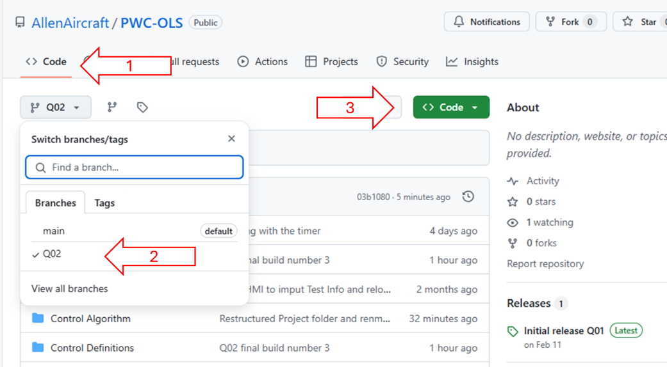

- Click on the green CLONE button then select “Download ZIP”
- Open the project zip file; navigate to ..\builds
- Copy folder MLOI-OLS LV Tester to the Target PC, default is desktop.
- Open the MLOI-OLS LV Tester folder, and create a shortcut to _MLOI_Q02.exe
- Move the shortcut to the desktop.
- Run the LV app by clicking on the new desktop shortcut.

  - Using Git Hints
To use the Windows Power Shell to run Git
- Use Windows explorer to navigate to the project folder where the ..git file resides.
- Right click in the white space, pick “Open in Termimal,;

A $ indicates input at the system prompt. The ellipses (. . .) separate the input from the response.
Creating a Local Project Folder
Navigate to the folder where you want the project folder to be created.
$ m:
$ cd “M:\OLS Level Test Project”
Browse to GitHub Repository, and copy the link under green Code button. Clone the project by pasting the copied link into the clone command.
$git clone https://github.com/AllenAircraft/MLOI-OLS.git
. . .
Cloning into 'MLOI-OLS'...
remote: Enumerating objects: 816, done.
remote: Total 816 (delta 0), reused 0 (delta 0), pack-reused 816 (from 1)
Receiving objects: 100% (816/816), 154.99 MiB | 50.92 MiB/s, done.
Resolving deltas: 100% (396/396), done.
Updating files: 100% (580/580), done.
Change directory to the project folder
M:\OLS Level Test Project>cd MLOI-OLS
, , ,
M:\OLS Level Test Project\MLOI-OLS>
Use checkout to select the working branch for this session.
$ git checkout QA02
. . .
Updating files: 100% (269/269), done.
branch 'QA02' set up to track 'origin/QA02'.
Switched to a new branch 'QA02'

Switching to a Remote Branch
To view origin link use Remote command
$ git remote -v
. . .
origin https://github.com/AllenAircraft/MLOI-OLS.git (fetch)
origin https://github.com/AllenAircraft/MLOI-OLS.git (push)

To see the current local branch
$ git branch
...
* main
q03

Start by fetching from the remote repository to make sure you have all the latest changes downloaded. This will fetch all of the remote branches.
$ git fetch -v
...
From https://github.com/AllenAircraft/MLOI-OLS
* [new branch] Q03 -> origin/Q03
* [new branch] Q04 -> origin/Q04
To see the branches available for checkout with:
$ git branch -v -a
...
* Q02 8077ba7 Q02 build 10030
remotes/origin/HEAD -> origin/Q02
remotes/origin/Q02 8077ba7 Q02 build 10030
remotes/origin/master 47df981 Change Name, old Q02

The branches that start with remotes/* can be thought of as read only copies of the remote branches. To work on a branch you need to create a local branch from it. This is done with the Git command switch giving it the name of the remote branch

$ git switch Q03
. . .
Updating files: 100% (233/233), done.
branch 'Q03' set up to track 'origin/Q03'.
Switched to a new branch 'Q03'
Switching to a Previous Commit
Find the commit of interest.
$ git log
, , ,
commit 6bd62e3a108793d552bd9fc1bac554126532c66e (HEAD -> QA02, origin/QA02)
Author: Rick Ales <ricka@allenaircraft.com>
Date: Thu Apr 17 09:49:13 2025 -0400

Q03 build 10040 mass compiled, built and runs no errors, still needs new Motor controller

commit 387ad1f989b2ec2ba121d89065491e0907f49afd
Author: Rick Ales <ricka@allenaircraft.com>
Date: Thu Apr 17 09:20:52 2025 -0400

Removed all vi within Allen Projects folder, only mXXX.vi and defs remain

commit 4e630795c203fbff75d286de08a1b85b0fb694ad
Author: Ri. . .

Switching to a different commit, detached the pointer from the head as it now points to the requested commit. There are two ways to switch back to the head

- Long way
Copy the commit ID (highlighted yellow above) and save to notepad file. This is needed to reset the pointer to HEAD. Copy the commit ID (highlighted cyan above) into the checkout command.
$ git checkout 387ad1f989b2ec2ba121d89065491e0907f49afd

- Short way
$ git switch –
If either way results in an error then you must either stash the change or undo your changes with the restore (highlighted in cyan):

$ git switch -
error: Your local changes to the following files would be overwritten by checkout:
_OLS_Main_Q02.vi
builds/PWC-OLS/$Calibration/CAL_Level_RnR_241105.xlsx
builds/PWC-OLS/$ConfigFiles/8005571-05 Elevate OLS .csv
builds/PWC-OLS/_OLS_Main_Q02.exe
Please commit your changes or stash them before you switch branches.
Aborting

$ git branch
* (HEAD detached at 9e9f5a1)
Q2_01
main

$ git restore *
$ git switch -
Previous HEAD position was 9e9f5a1 fix test protocol bug, redesigned timer, added some tool tips
Switched to branch 'Q2_01'
Your branch is up to date with 'origin/Q2_01'.

$ git branch
* Q2_01
main

Create a new branch and save to remote GitHub

Starting fron an exixting branch

$ git status
* On branch Q2_01
Your branch is up to date with 'origin/Q2_01'.

Create a new local branch

$ git checkout -b Q2_02
* Switched to a new branch 'Q2_0

$ git status
* On branch Q2_02
nothing to commit, working tree clean

PS C:\AllenProjects\PWC-OLS> git push Q2_02
.
$ git push -u origin Q2_02
Total 0 (delta 0), reused 0 (delta 0), pack-reused 0 (from 0)
remote:
remote: Create a pull request for 'Q2_02' on GitHub by visiting:
remote: https://github.com/AllenAircraft/PWC-OLS/pull/new/Q2_02
remote: To https://github.com/AllenAircraft/PWC-OLS.git
* [new branch] Q2_02 -> Q2_02
branch 'Q2_02' set up to track 'origin/Q2_02'.

To switch to the new branch
$ git branch
* Q2_01
Q2_02
Main

$ git switch Q2_02
* Switched to branch 'Q2_02'
Your branch is up to date with 'origin/Q2_02'.
Add a Prefix to the Names of Multiple Files in Power Shell

Change directory to where the files are contained

Copy and Paste the following command into power shell, then change the “x” to what ever text to want to prepend to all the file names in the directory.

$ cd test
$ (Get-ChildItem -File) | Rename-Item -NewName {$_.Name -replace "^","x"}
$ dir

Directory: C:\AllenProjects\PWC-OLS\test
Mode LastWriteTime Length Name
---- ------------- ------ ----
-a---- 4/26/2025 6:35 AM 28306 x$CTL_LevelCtlr.vi
-a---- 4/26/2025 6:35 AM 30261 x$CTL_LevelCtlrQ02.vi
-a---- 4/26/2025 6:35 AM 17868 x$CTL_Limit Check.vi

(Get-ChildItem -File) | Rename-Item -NewName {$_.Name -replace "^","x"}

